Lachlan Series Bathroom Accessories

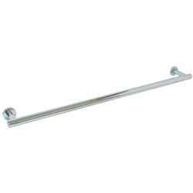
Material Specifications
- Brass
- Bright Chrome Plate Finish

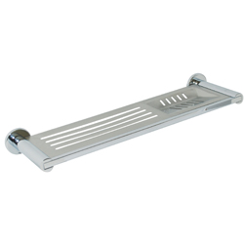
Dimensions
- ML6204 Single Towel Bar – 700mmW x 40mmH x 85mmD (660mm C to C)
- ML6216 Combined Shelf & Soap Dish – 350mmW x 40mmH x 107mmD (330mm C to C)
ML6204
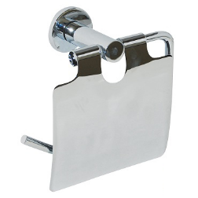
- ML6224 Single Toilet Roll Holder with Hood – 145mmW x 90mmH x 85mmD
- ML6225 Single Toilet Roll Holder –
145mmW x 90mmH x 85mmD
ML6216 ML6204

- ML6227 Square Towel Holder – 130mmH x 85mmD
- ML6230 Robe Hook – 60mmD x 40mmØ
- ML6226 Single Toilet Roll Holder –
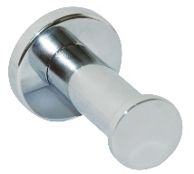
170mmW x 76mmD
ML6224

Installation Guidelines
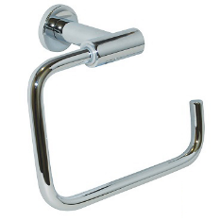
- May be subject to Australian Building Code Regulations for height and location fixing and may be subject to placement as per architectural drawings. In all cases, this is the responsibility of the installer.
ML6230

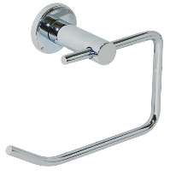
- Loosen Grub Screw (B) in Mounting Support (A) with Hex Key (C) and remove Wall Mount Bracket (F) and separate from Cover (D).
ML6227

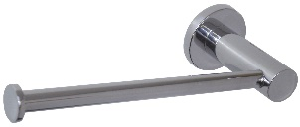
- Locate height of relevant Lachlan fixture and using one slotted and one opposing hole in Wall Mount Bracket (F), align so as indent on shaft faces downwards (Grub Screw aligns into the indent) and mark fastening locations onto the surface being affixed to (a minimum of 2 anchor points per Wall Mount Bracket (F) MUST be used).
ML6225
ML6226
- Note: For dual Mounting Support application, ensure that height positions are parallel and Centre to Centre measurements are correct.


- Drill holes in marked positions, insert Hard Wall Anchors (G) or other suitable fasteners appropriate to the surface being affixed to.

This product is AS1428.1 compliant (accessible compliant) when installed in accordance with the guidelines.

- Place Screws (E) through Wall Mount Bracket (F) and loosely tighten Screws (E) into Anchors (F) and recheck and/or adjust alignment, then firmly secure Screws (E) to hold Wall Mount Bracket (F) firmly to surface being affixed to.

5. Position Cover (D) over Wall Mount Bracket (F) then slide Mounting Support (A) onto shaft of Wall Mount Bracket (F) and secure Grub Screw (B) ensuring it
aligns into the indent.
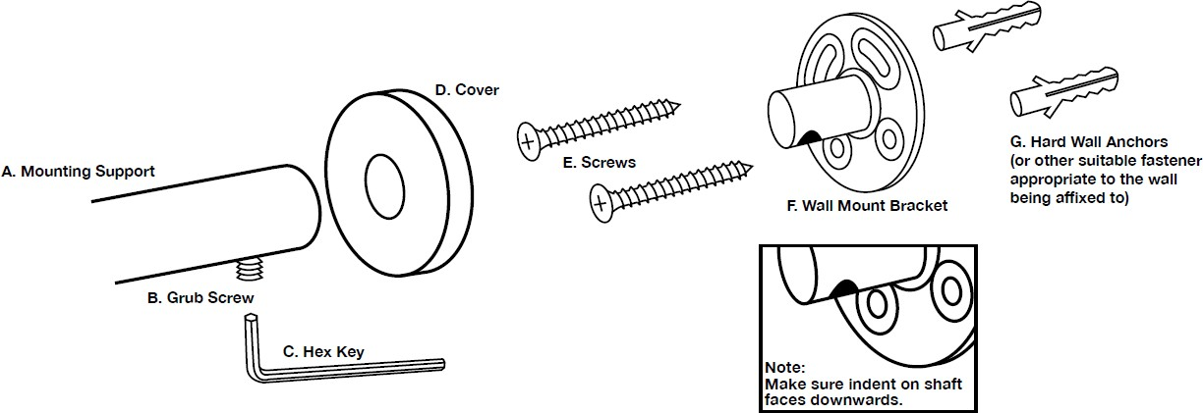
The technical recommendations contained in this document are necessarily of a general nature and should not be relied on for specific applications without first securing competent advice. Whilst Metlam Australia Pty Ltd has taken all reasonable steps to ensure the information contained herein is accurate and current, it does not warrant the accuracy or completeness of the information and does not accept liability for errors or omissions. Any Commercial product should only be installed by a competent tradesperson and serviced/maintained by knowledgeable janitorial staff or competent people. Metlam Australia accepts no responsibility for any damage to product, walls or fixtures due to
incorrect installation or maintenance of any of their products.

The photographs and line drawings of the products presented above are representational only.
Metlam Australia Pty Ltd reserves the right to, and from time to time, make changes and improvements in design and dimensions.

